SBC AWS Landing Zone Project

# VPC Provisioning in AWS Control Tower using Service Catalog

**Version 1.5 Date: 22-Aug-2022**

Table of Contents

VPC Provisioning in AWS Control Tower using Service Catalog 1

Table of Contents 1

1 Overview 2

2 Prerequisite(s) 2

3 Configure Account Factory with custom Amazon VPC settings 6

4 Create a launch constraint role across the organization 9

5 Deploy Pre-requisite in the member account through automation 12

6 Deploy the portfolio in the AWS Service Catalog delegated administrator account 15

7 Share the newly created portfolio with your organization from Delegated Administrator account 16

8 Setup user access and provision a custom VPC using AWS Service Catalog 19

9 Setup user access and provision another custom VPC in the same AWS Account 24

10 Approach to Create Products in Single step 28

11 Appendix A 28

12 Document Control - Version History 29

Overview

This document describes VPC Provisioning in AWS Control Tower using Service Catalog

Prerequisite(s)

Prerequisites are information and details of understanding that need to be obtained before progressing

* 1. A network account with a transit gateway provisioned which has auto-accepted attachment requests enabled. Make a note of your transit gateway ID. This will be used in the solution.
  2. Resource sharing with AWS Organizations should be enabled
  3. AWS Resource Access Manager configured to share the transit gateway with your organization in AWS Organizations
  4. Trusted access with AWS Cloud Formation stack sets should be enabled
  5. AWS Service Catalog delegated administrator should be set up
  6. Make any AWS account as AWS Service Catalog delegated administrator account by running the following commands.



* 1. Create S3 bucket in AWS Service Catalog delegated administrator account, for VPC files.
  2. Create a new Permission Set in the Management Account.
     1. Login to the AWS Control Tower Management Account using **AWSAdministratorAccess** role.
     2. Under **Find Services** search bar type **IAM Identity Center**.

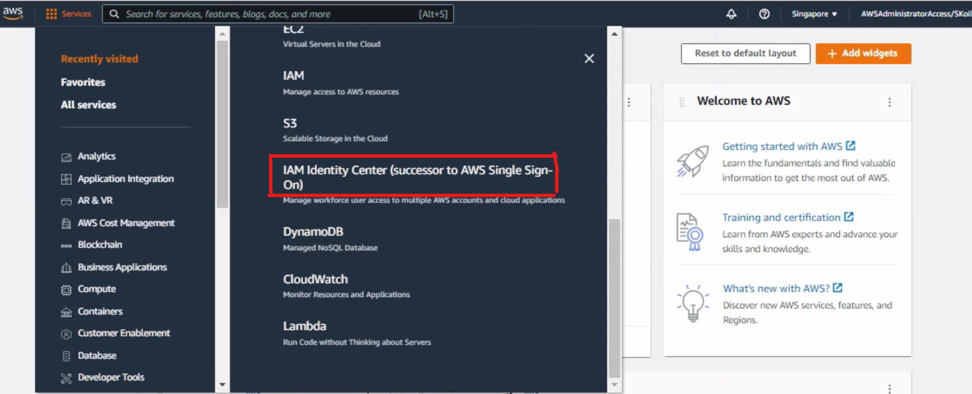

* + 1. Select **AWS accounts** on the left side bar.

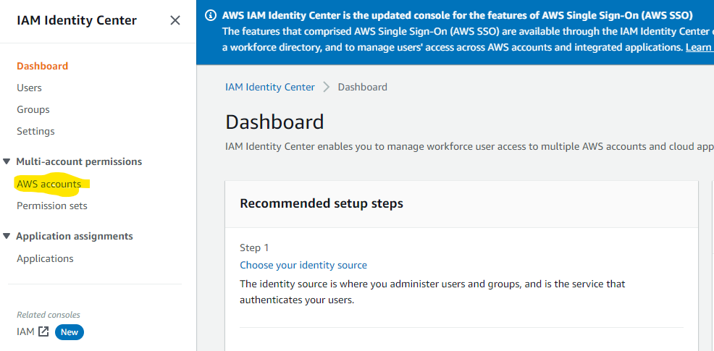

* + 1. In AWS Accounts page, select **Permission sets** tab, and click **Create permission set** button.

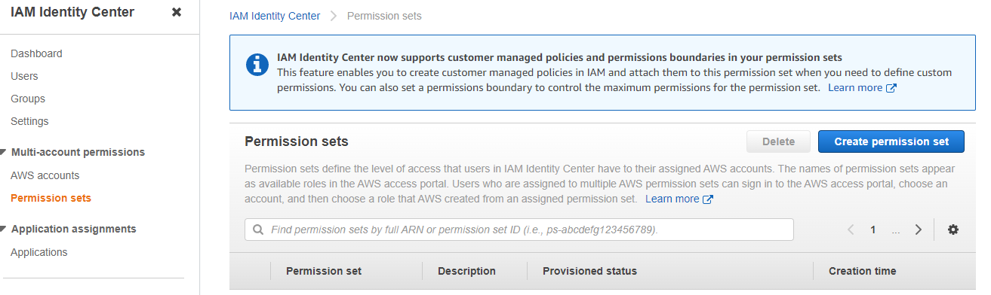

* + 1. In Create new permission set page, create a **custom permission set**.

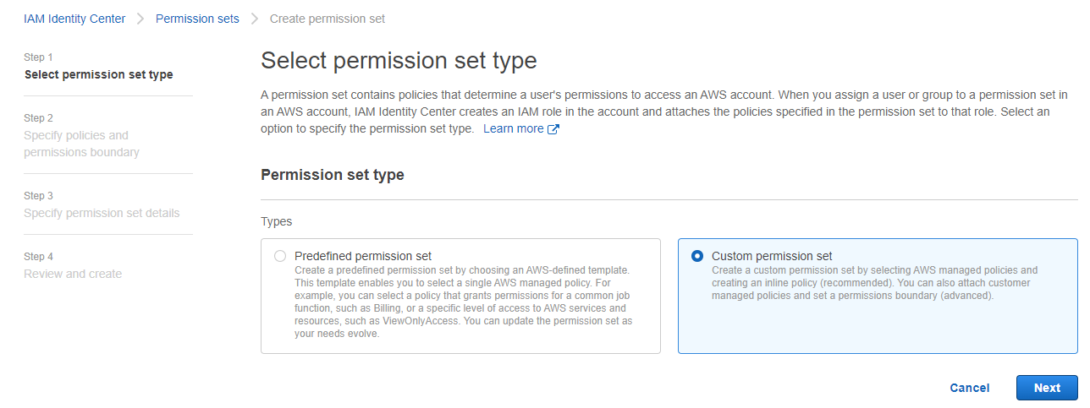

* + 1. Under **Specify Policies and Permission Boundaries,** select **Attach AWS managed policies.**

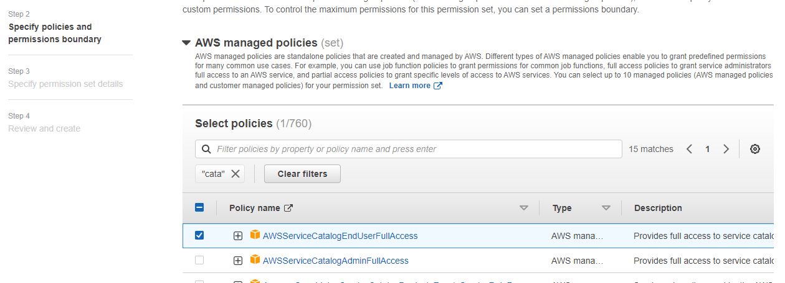

* + 1. Under **Inline Policy,** paste the following file and click **Next**.



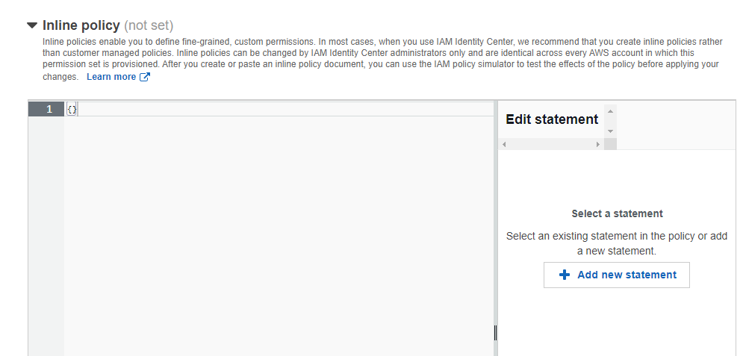

* + 1. Type ***DeveloperAccessPermissions*** for **Name** and enter some **Description** to the Role and click on Next and click on **Create.**
  1. Assign permission set to AWS SSO User/Group.

1. Now click on the **AWS accounts** on the left sidebar and select the account that you like to grant ***DeveloperAccessPermissions*** permissions.
2. Select the AWS Account and Click on **Assign users**, and select the **Users** tab, and select the username and click **Next.**

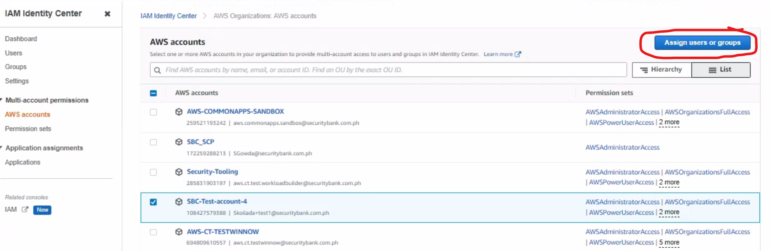

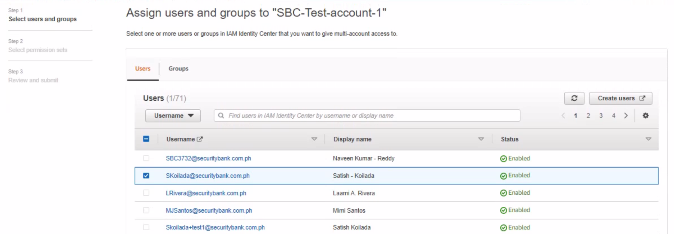

1. In **Assign permission sets** page, select **DeveloperAccessPermissions** and click on **Next** and then click on **Submit.**

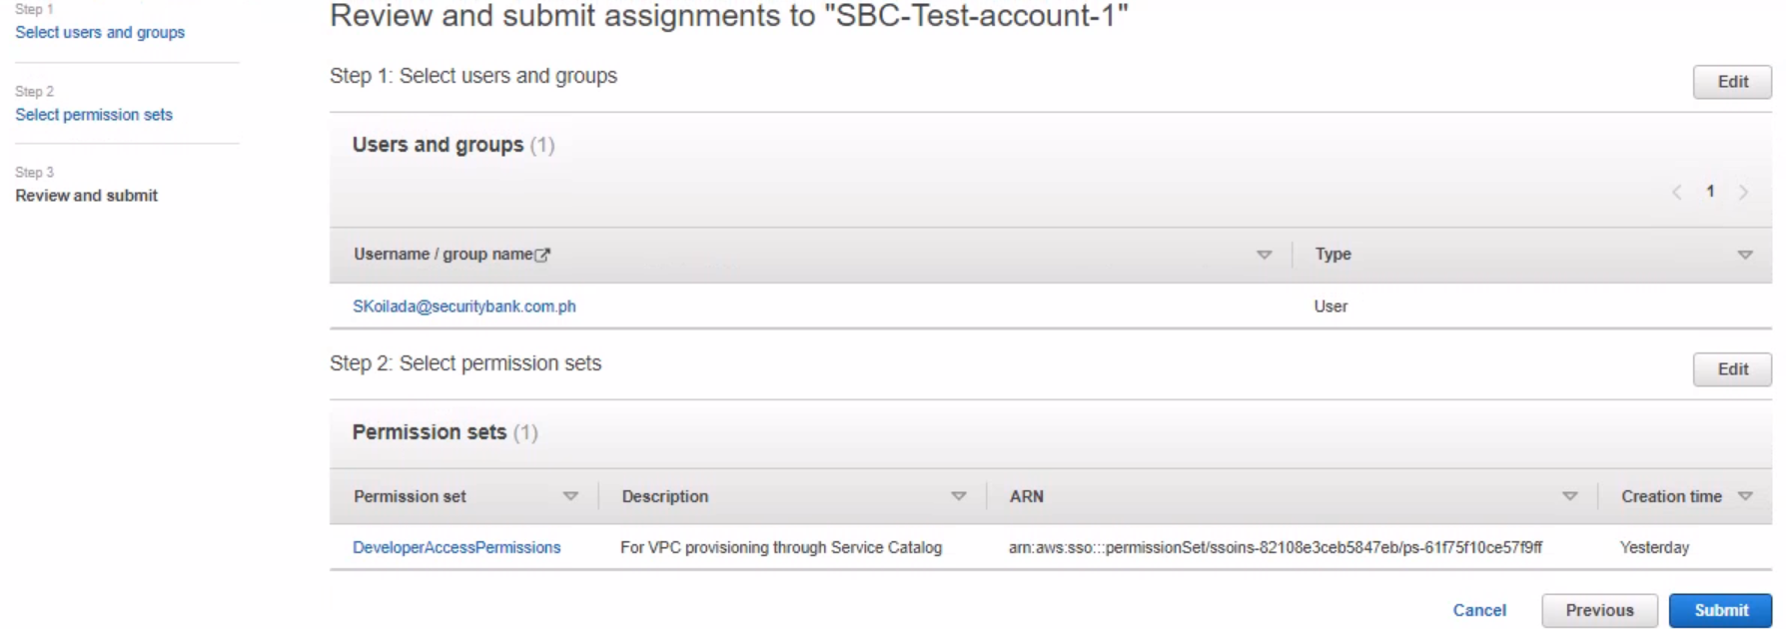

* 1. Provide SSM full access to Service-Catalogue-VPC-Launch.

Configure Account Factory with custom Amazon VPC settings

* 1. **Destination Account Factory enables you to configure VPC options when you provision new AWS accounts. In this solution however, we will elect not to use the default settings**

We will disable the provisioning of a VPC and use a self-service VPC in AWS Service Catalog instead

* + 1. Follow these steps to disable the provisioning of a VPC on account creation
    2. In the AWS Control Tower console, choose Account Factory
    3. Under Network configuration, choose Edit

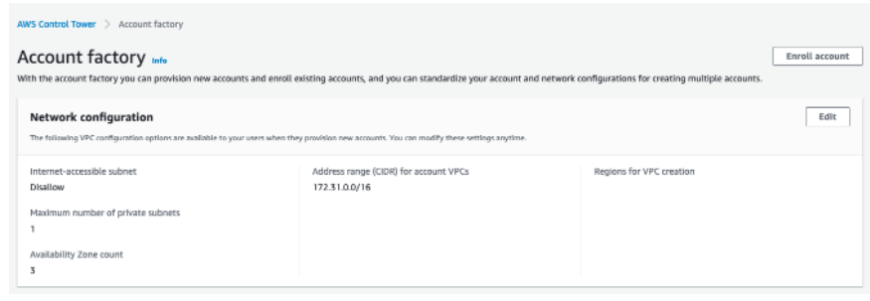

* + 1. On Edit account factory network configuration, clear all check boxes under Regions for VPC Creation, and then choose Save.

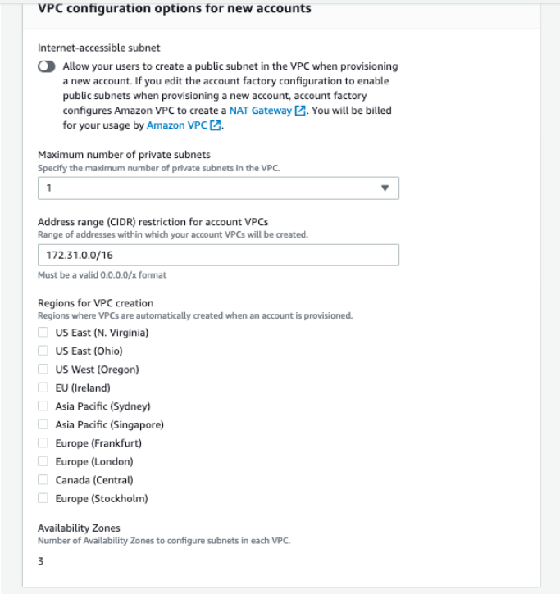

Create a launch constraint role across the organization

You must first have the appropriate role in the new account for AWS Service Catalog to share and instantiate your AWS Cloud Formation stack set. Once this IAM role is in the account, we can use it as a launch constraint within AWS Service Catalog. This will allow your end users to provision these VPCs without each user having VPC console access. This follows the least privilege rule, and will help with automation of this capability in the future as well

* 1. To launch the AWS Cloud Formation stack set in the management account and create stack and provide the following URL

<https://marketplace-sa-resources-ct-us-east-1.s3.amazonaws.com/ct-blogs-content/launch-constraint-role.cf.yml>

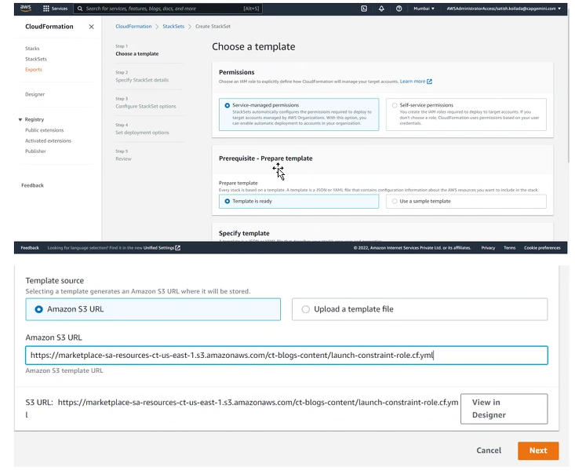

* 1. Choose Next
  2. On the Specify Stack Set details page, enter a stack set name (for example, vpc-portfolio-launch-role)
  3. In Parameters, for pRoleName, enter a name for the role (for example, service-catalog-vpc-launch). Make a note of this name because you will use it when you deploy the AWS Service Catalog portfolio.
  4. Choose Next
  5. On the Configure StackSet options page, choose Service Managed Permissions, and then choose Next
  6. In Deployment targets, choose Deploy to organization. In Automatic deployment, choose Enabled. In Account removal behavior, choose Delete stacks

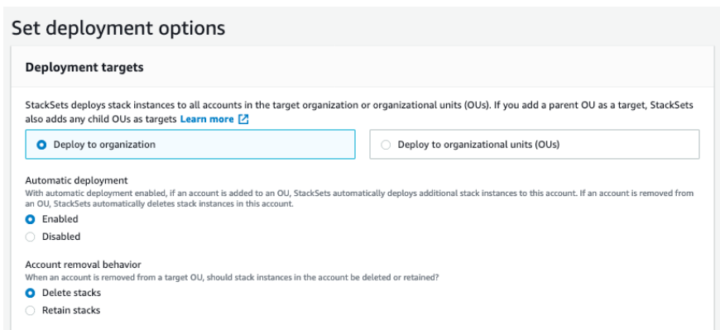

* 1. In Specify Regions, choose your AWS Control Tower home Region. Add only one Region to the list, as IAM roles are global resources. If you choose more than one Region, the stack deployment will fail.
  2. In Deployment options, accept the defaults provided.

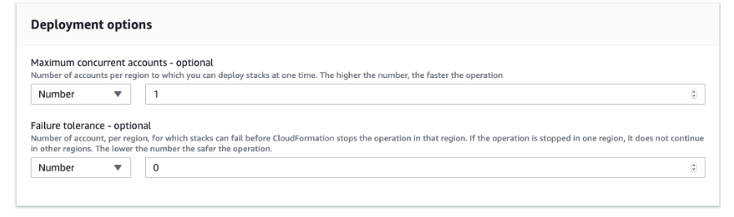

* 1. Review your selections, and then choose Submit.
  2. Verify that the stack set has been created successfully before you move to the next step

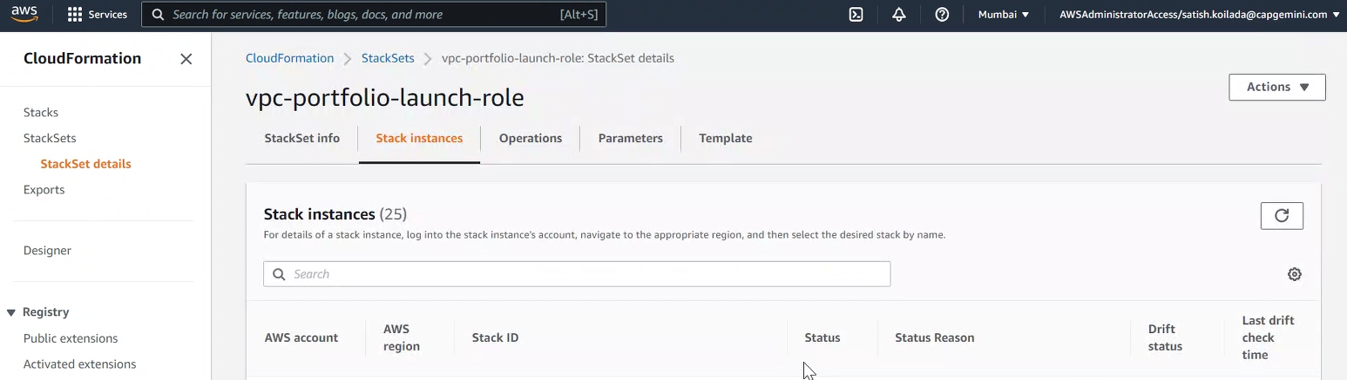

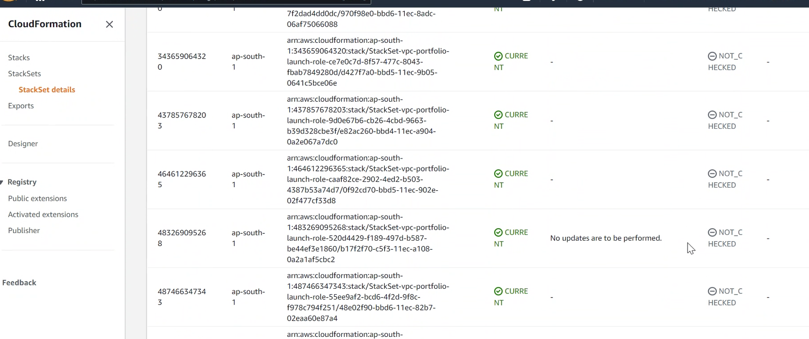

Deploy Pre-requisite in the member account through automation

* 1. Login to the SSO Member Account.

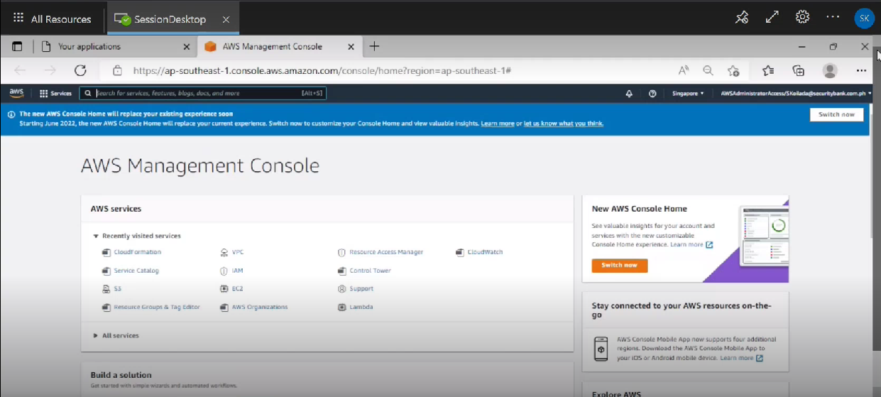

* 1. Navigate to S3 service and create a bucket named “sbc-pre-requisites” and upload **Vpc-provisioning-Pre-requisites-v.4.yml**

**Note**: 

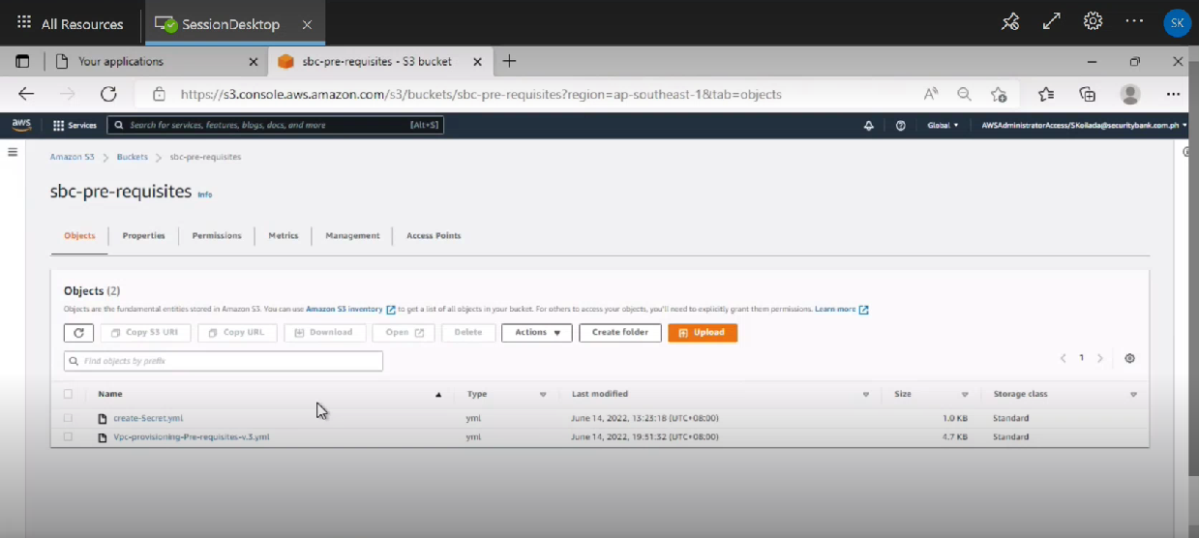

* 1. Copy the object URL of file **“Vpc-provisioning-Pre-requisites-v.4.yml”**

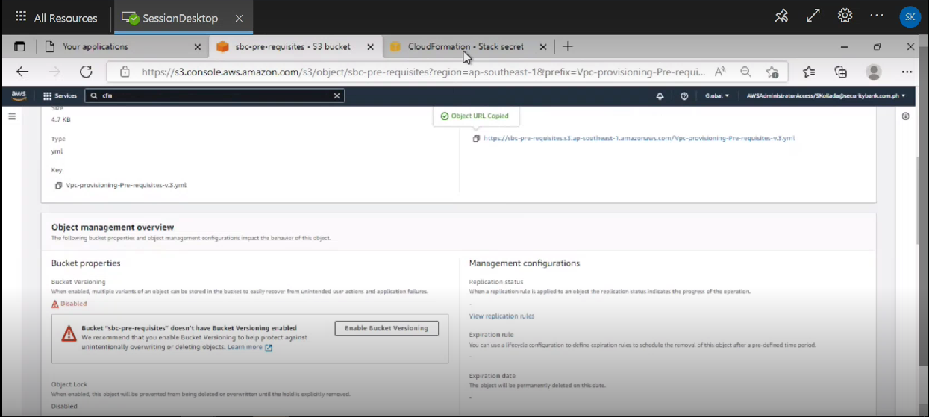

* 1. Navigate to the Cloud formation Service and Create a stack and paste the Object URL

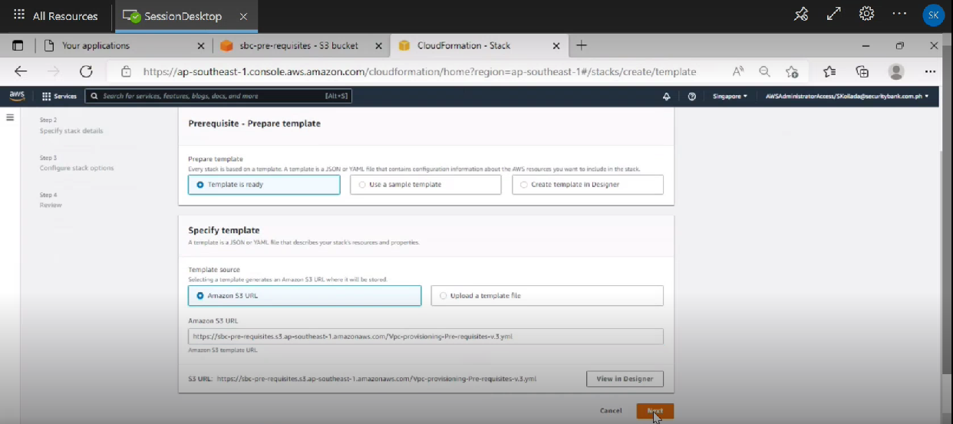

* 1. On the Specify stack details page, enter a stack name, click on next -> next -> create stack

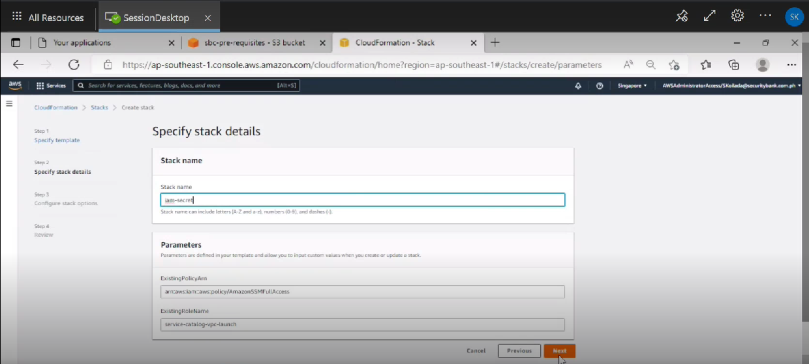

* 1. You can see the stack is created successfully.

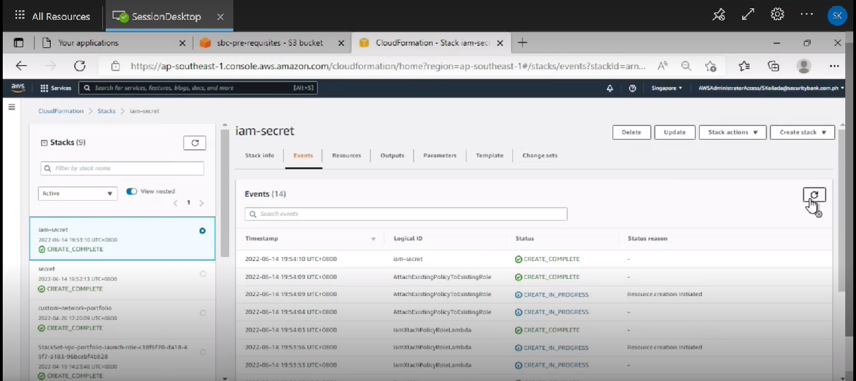

* 1. You can see that “SSM Full Access” policy is attached to the “service-catalog-vpc-launch” role.

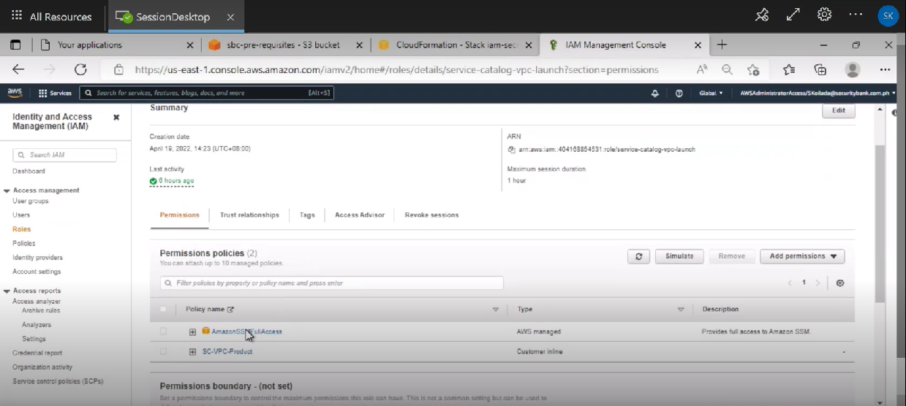

Deploy the portfolio in the AWS Service Catalog delegated administrator account or Update Existing Stack

* 1. Navigate to Cloud Formation template and create a Network-Portfolio Stack and provide the S3 URl detail which had been mentioned in above 2.7 Prerequisite



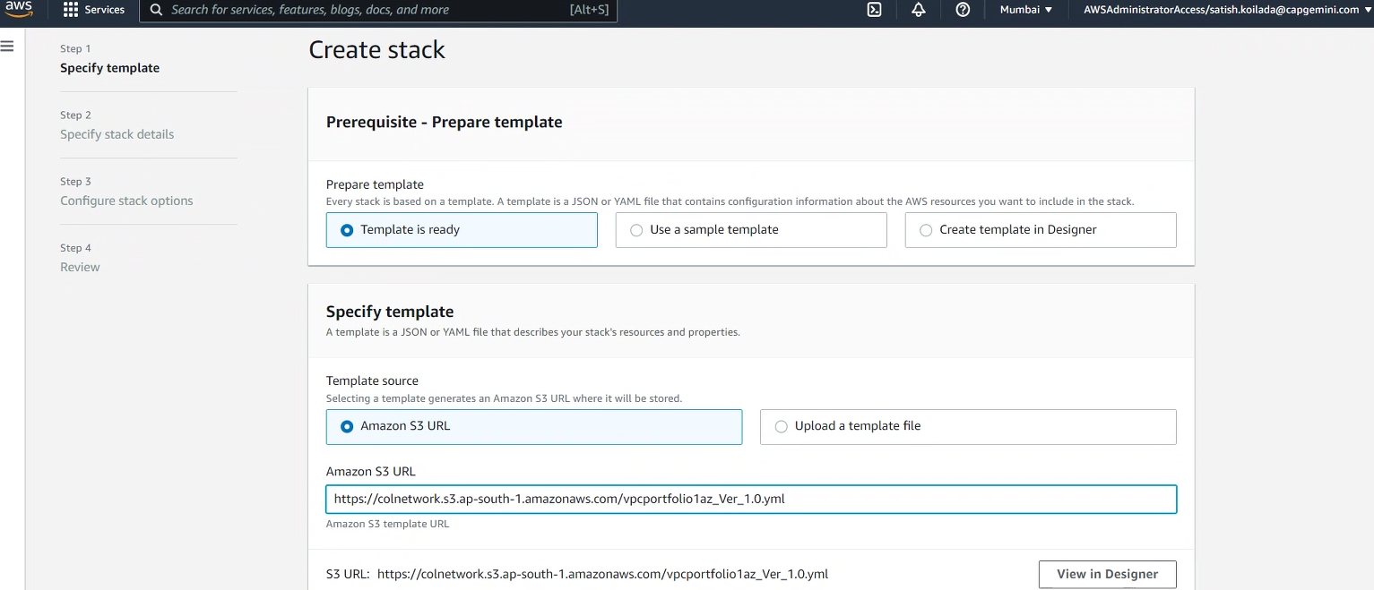

* 1. On the Specify stack details page, enter a stack name (for example, custom-network-portfolio).
  2. On the Specify stack details page, enter the following parameters:
  3. **pVpcLaunchRoleName**: Enter the role name that you used earlier. AWS Service Catalog uses this role to launch the VPC product.
  4. **pPortfolioName**: Enter a name for the portfolio (for example, Self-Service Network Portfolio).
  5. **pVpcProductKey**: Accept the default Amazon S3 location for the VPC product template.
  6. Choose Next.
  7. On the Configure Stack Options page, enter any tags you want to assign to the stack, and then choose Next.
  8. Select the IAM acknowledgement check box, and then choose Create Stack.
  9. Verify that the stack has been created successfully before you move to the next step

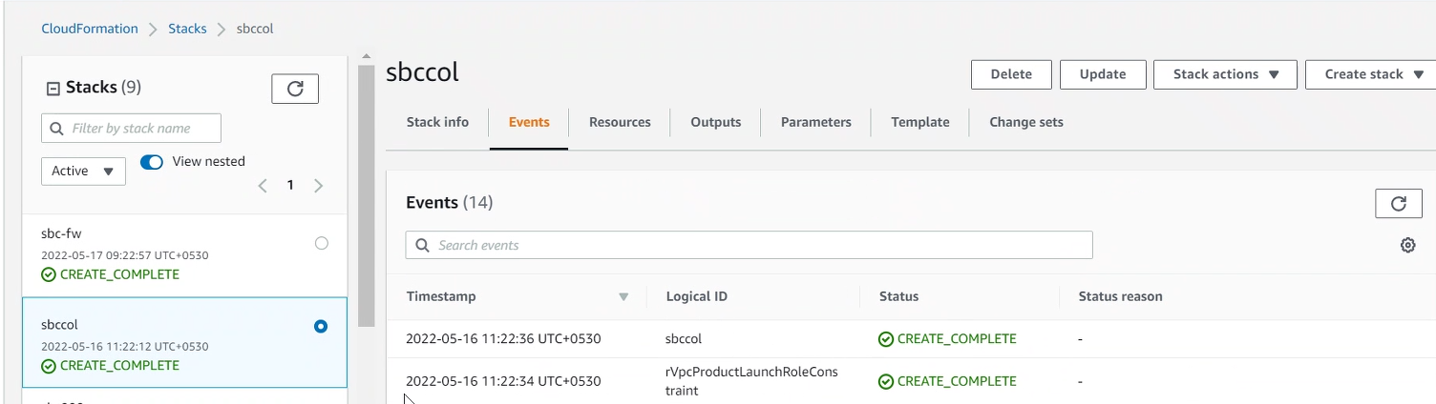

* 1. If you want to update the existing stack, please follow this user guide.



Share the newly created portfolio with your organization from Delegated Administrator account

* 1. Open the AWS Service Catalog console, and from the left navigation pane, choose Portfolios.
  2. Choose the radio button next to Self-Service Network Portfolio, and from Actions, choose Share.

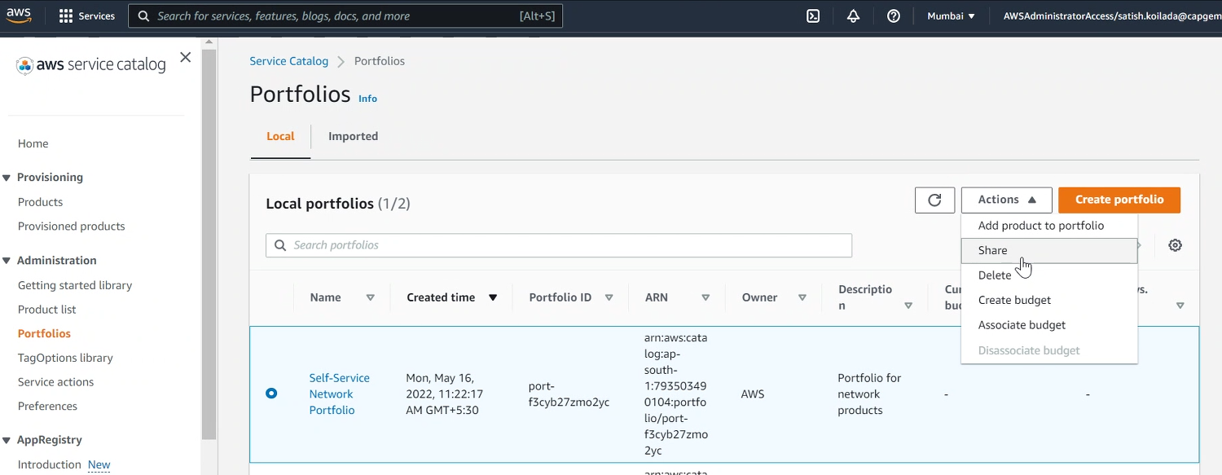

* 1. On Create share: Self-Service Network Portfolio, under Select how to share, choose Organization.
  2. Under Select an organizational entity to share with, choose Organization.
  3. Under Organization, select the account to which you want to share, enable TagOption Sharing and then choose Share.

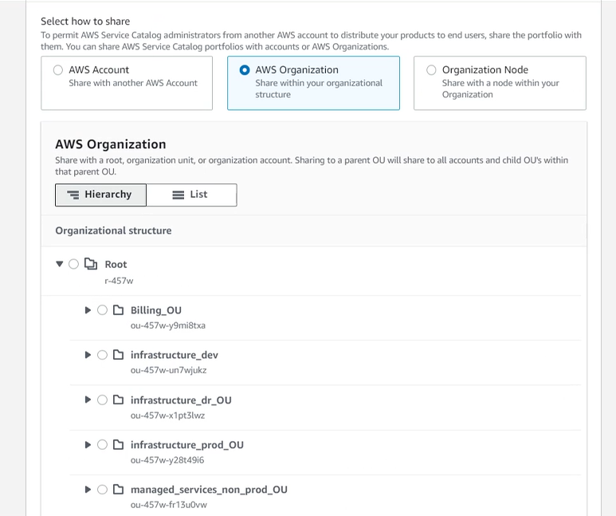

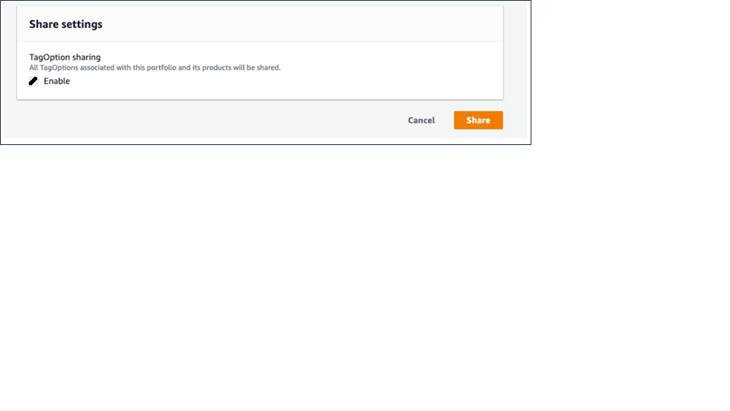

Setup user access and provision a custom VPC using AWS Service Catalog

* 1. Login into the SSO member account using **AWSAdministratorAccess** and Navigate to Service Catalog Service and click on Portfolios.

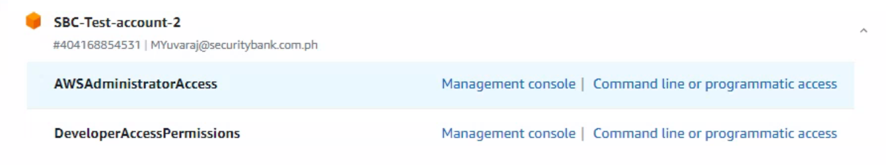

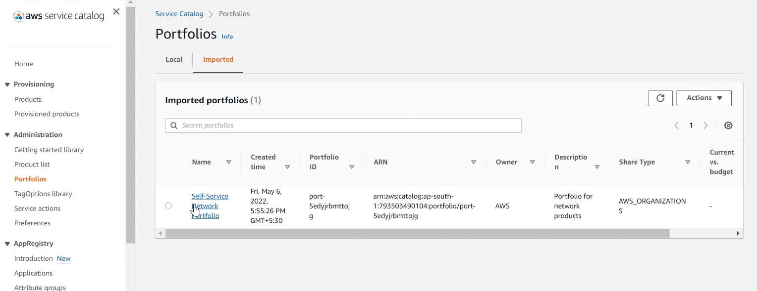

* 1. Select **Groups, Roles and Users.**

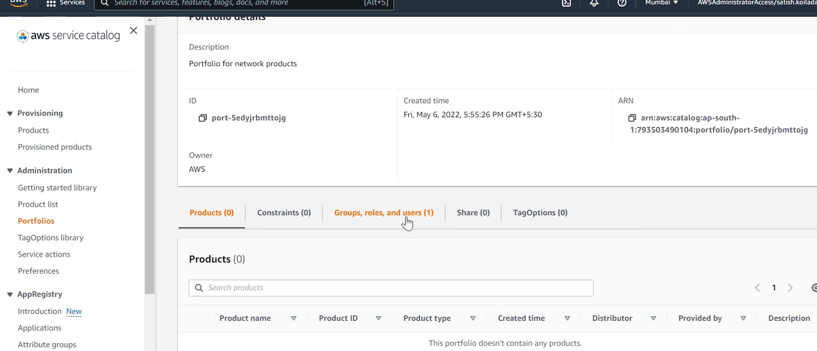

* 1. Select **Roles** and search for **DeveloperAccessPermissions** permission setwhich was created in Pre-Requisites 2.8and click on **Add Access.**

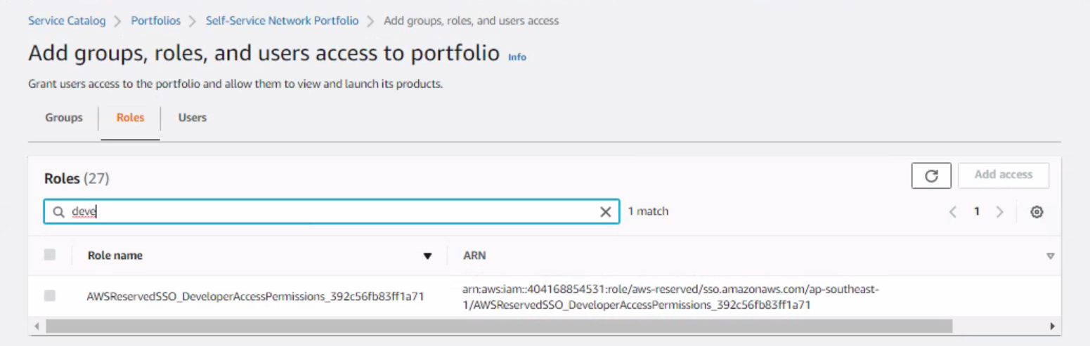

* 1. Login to the SSO member account using **DeveloperAccessPermissions** role and Navigate to Service catalog and click on Products

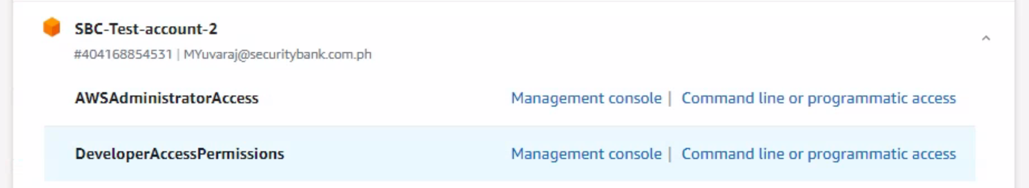

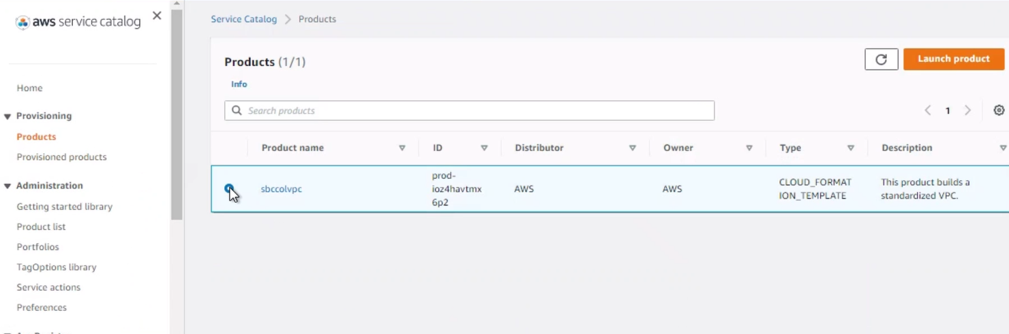

* 1. Now, Click on launch Product

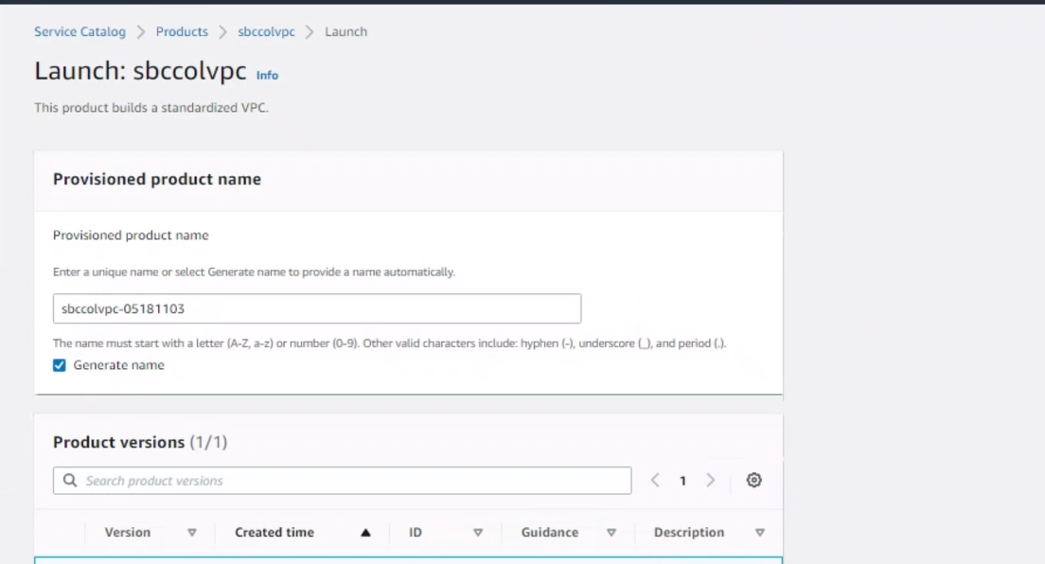

* 1. Fill the Parameter Section a shown in below screen

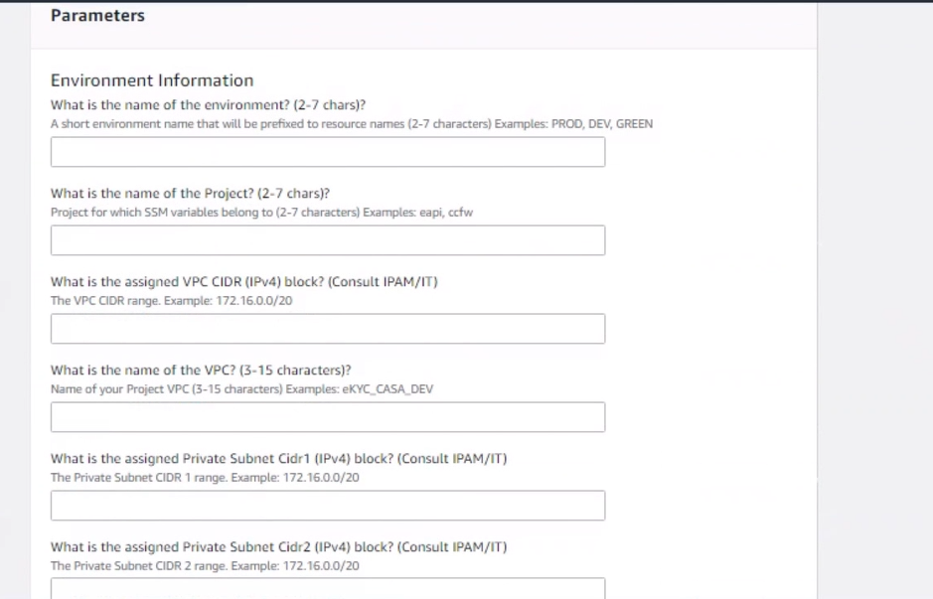

* 1. After filling all the required parameters, click on Launch Product.

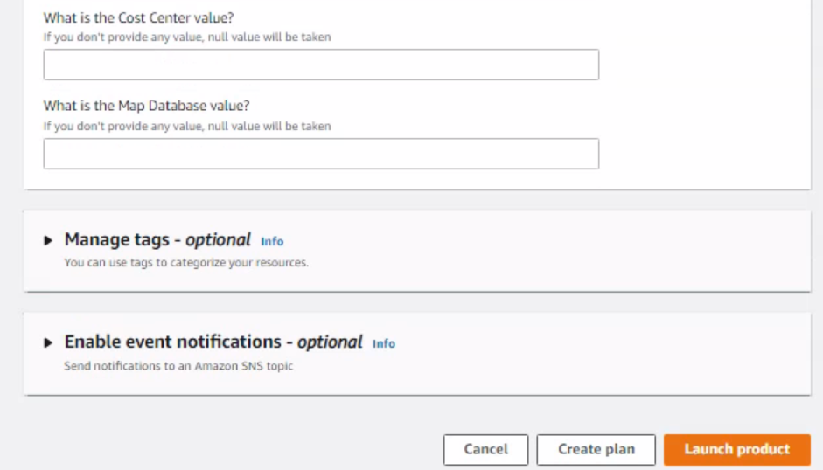

* 1. Once the Launch Product status is available, the product is launched successfully.

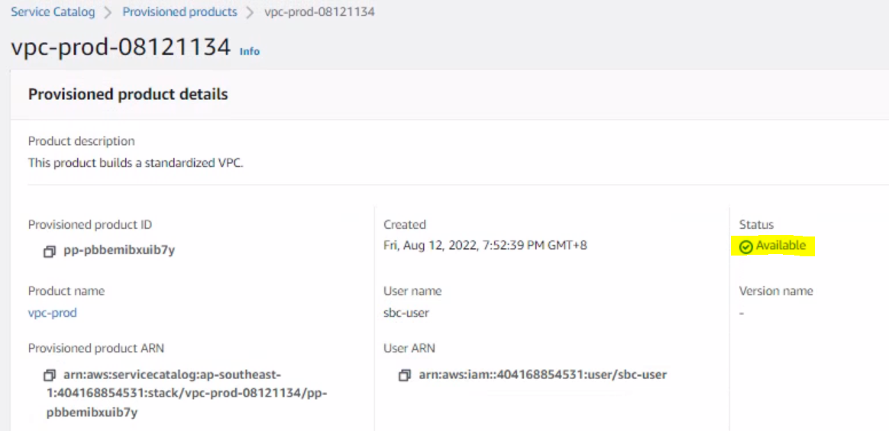

* 1. Verify that all the resources are created in the Resource Section below.

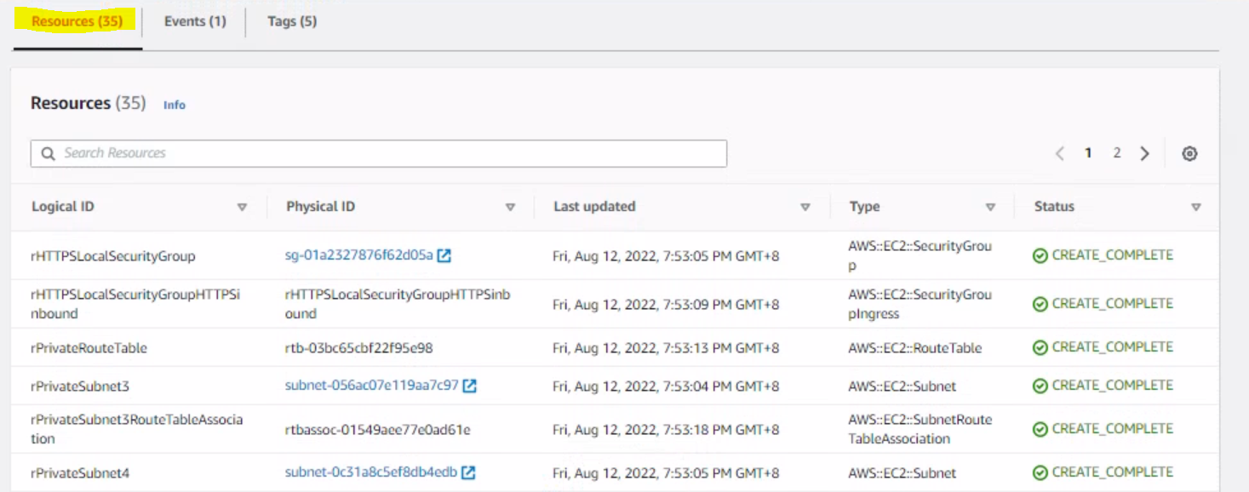

* 1. Verify the SSM parameter are created in System Manager in Parameter store Tab

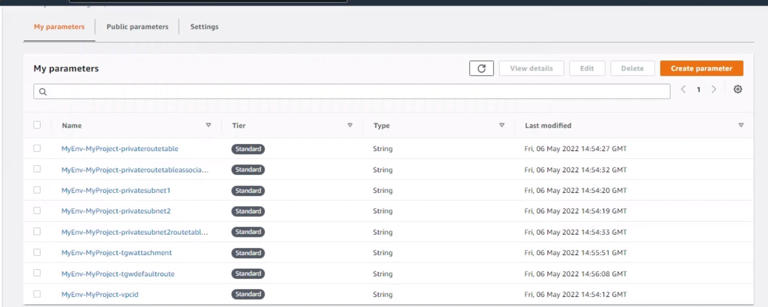

* 1. Verify the VPC Subnets, Route Tables, TGW attachments are successfully created

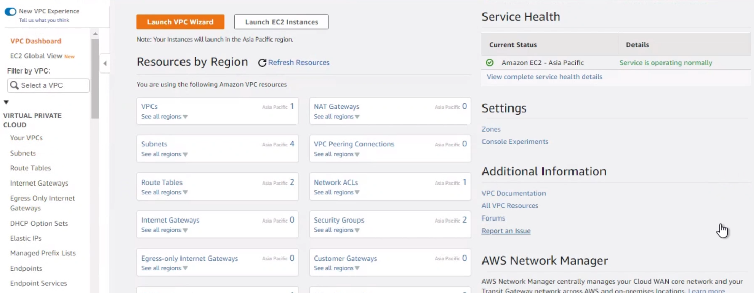

Setup user access and provision another custom VPC in the same AWS Account

* 1. To create another custom VPC in the same account, navigate to Service catalog -> Products. Select the VPC Product and click on Launch Product.



* 1. Fill the Parameter Section as shown in below screen.





* 1. After filling all the required parameters, click on Launch Product.



* 1. Once the Launch Product status is available, the product is launched successfully.



* 1. Verify that all the resources are created in the Resource Section below.



* 1. Verify the SSM parameter are created in System Manager in Parameter Store Tab.



* 1. Verify that the VPC Subnets, Route Tables, TGW attachments are successfully created.



Approach to Create Products in Single step

* 1. Create stacks for different portfolios contains different number of subnets in the delegated Administrator Account at a time and then share them to the respective member accounts.
  2. This will eliminate the steps to update the stack repeatedly.

Appendix A

**A.1** The naming convention we followed is as follows:-

sbc-**<**product_name**>**-**<**no_of_AvailabilityZone**><**no_of_subnet_per_AvailabiltyZone**>**

**Example**: sbc-vpc-1az1sub, sbc-portfolio-1az1sub

**A.2** S3 bucket named “**sbc-vpc-provisioning**” keeps folders and files as follows:-

1. **sbc-1az1sub**



1. sbc-vpc-1az1sub
2. sbc-portfolio-1az1sub
3. **sbc-2az2sub**



1. sbc-vpc-2az2sub
2. sbc-portfolio-2az2sub
3. **sbc-2az4sub**



1. sbc-vpc-2az4sub
2. sbc-portfolio-2az4sub

Document Control - Version History

|  |  |  |  |  |  |  |
| --- | --- | --- | --- | --- | --- | --- |
| **AMENDMENT LOG** | | | | | | |
| **Version** | **Date**  **dd-mmm-yyyy** | **Prepared By** | **Reviewed By** | **Section** | **A/M/D** | **Brief Description of change** |
| 1.0 | 18-May-2022 | Satish Koilada and Somalinga Gowda | SBC | All | A | Initial version of VPC provisioning steps |
| 1.1 | 17-Jun-2022 | Satish Koilada | SBC | 5 | A | Section-5 is for deploying pre-requisites using automation |
| 1.2 | 27-Jun-2022 | Sagarika Kanikella | SBC | 10 | A | Added Appendix A |
| 1.3 | 12-Aug-2022 | Sagarika Kanikella | SBC | 9 | A | Section-9 is for adding another custom VPC in the same AWS account. |
| 1.4 | 16-Aug-2022 | Sagarika Kanikella | SBC | 10 | A | Section-10 are approach to create products in single step. |
| 1.5 | 22-Aug-2022 | Sagarika Kanikella | SBC | 8 | A | Section-8 is new way for VPC Provisioning. |